CORAL BLEACHING FORECASTING
Tran Hung Khang

Abstract
The report presents an experiment on forecasting and monitoring coral bleaching risks around Lizard Island, in the northern Great Barrier Reef, based on NOAA Coral Reef Watch data. The dataset includes a daily observation series from 2010-01-01 to 2025-02-08 across six spatial grid cells, featuring thermal characteristics and warnings that include SST, SST anomaly, HotSpot, Degree Heating Weeks (DHW), Bleaching Alert Area, and BAA 7-day maximum composite. The problem is designed in a multi-task direction: forecasting DHW after 28 days and predicting the corresponding bleaching alert level. The compared models include Random Forest, XGBoost, LightGBM, LSTM, GRU, CNN-LSTM, a reduced Temporal Fusion Transformer, and a Spatio-Temporal Graph Neural Network. The results indicate that the TFT achieves the lowest DHW forecast error, while CNN-LSTM and LSTM demonstrate relatively good efficiency in classifying warning levels within the deep model group. The result analysis also highlights that class imbalance is the primary challenge for the severe event warning problem.

1. Introduction
Coral bleaching is a severe ecological phenomenon that occurs when coral is subjected to environmental stress, particularly prolonged thermal stress, leading to the loss of symbiotic algae and a decline in physiological functions. For reef ecosystems, this phenomenon not only reflects short-term fluctuations in sea surface temperatures but also demonstrates the cumulative impact of thermal stress over time. Therefore, monitoring and early forecasting of bleaching risks have direct implications for coral reef conservation, marine protected area management, and response planning for marine heatwaves.
NOAA Coral Reef Watch provides satellite products for monitoring coral thermal stress on a global scale, where variables such as HotSpot, Degree Heating Weeks (DHW), and Bleaching Alert Area (BAA) are designed to reflect the level of bleaching risk over time. In this experiment, NOAA CRW products are used as the primary foundational data to build a forecasting pipeline. The objective of the study is to evaluate the capabilities of various machine learning and deep learning model groups across two related tasks: forecasting thermal stress intensity via DHW and forecasting the bleaching alert level 28 days in advance.
The main contributions of the experiment consist of three points. First, the report establishes a reproducible evaluation process where data, features, models, and evaluation metrics are uniformly organized. Second, the experiment compares both robust tabular models and deep time-series models, helping to clarify the relative advantages of each method group. Third, the report deeply analyzes data characteristics, especially seasonality, extreme thermal stress years, and alert class imbalance, thereby explaining the experimental limitations of the forecasting results.
2. The Meaning and Role of Features
2.1 Sea Surface Temperature
Sea Surface Temperature (SST) is the sea surface temperature at the time of observation. This is a foundational feature because coral bleaching is often directly related to temperature increases that exceed the coral's physiological adaptation conditions. SST is significant in describing the instantaneous thermal state, but using SST alone makes it difficult to distinguish a normal seasonal hot day from an abnormally stressed day. Therefore, SST must be interpreted alongside anomalous and cumulative features.
In the experimental dataset, the spatial average SST ranges from 22.51 to 30.69 degrees Celsius, with an average value of 26.94 degrees Celsius. This fluctuation range indicates that the study area has a distinct thermal seasonality. Models need to learn this seasonal structure to avoid treating every high SST value in the summer as a strong warning signal.
2.2 SST Anomaly
SST anomaly measures the deviation of SST compared to the baseline or climatological conditions in the same area. This feature is more meaningful than absolute SST when the goal is to detect anomalies, as it partially normalizes the impacts of seasonality and geographical location. Two identical SST values can carry different ecological meanings if they appear at different times of the year; the SST anomaly helps the model recognize this difference.
In terms of forecasting, the SST anomaly often acts as an early signal for the formation of thermal stress. When a positive anomaly is prolonged, the probability of HotSpot and DHW increasing in the subsequent days is also higher. Therefore, this feature supports both the DHW regression problem and the alert classification problem.
2.3 HotSpot
HotSpot reflects the extent to which SST exceeds the maximum climatological threshold. Unlike the general SST anomaly, HotSpot focuses directly on the heat portion exceeding the threshold that is relevant to bleaching risk. If the HotSpot is small or negative, the thermal conditions are generally not strong enough to accumulate bleaching stress; if the HotSpot is positive and prolonged, DHW tends to increase.
In the pipeline, HotSpot plays a dual role. On one hand, it is an input variable for the forecasting model. On the other hand, it participates in defining the bleaching alert level alongside DHW. This makes HotSpot a feature closely related to the classification label, while also holding clear interpretive value regarding ecological mechanisms.
2.4 Degree Heating Weeks
DHW is a cumulative measure of thermal stress over several weeks. This feature is important because the coral's bleaching response usually depends on total prolonged stress rather than the temperature on a single day. The higher the DHW, the greater the bleaching risk; the thresholds of 4 and 8 DHW are frequently used to differentiate more severe alert levels in the NOAA CRW system.
In the experiment, DHW serves as both an input feature and the regression target variable after 28 days. Incorporating past DHW into the model helps to learn the inertia of thermal stress: when DHW has accumulated to a high level, it typically does not decrease immediately but depends on thermal developments in the following weeks. This explains why the lag and rolling features of DHW hold high predictive value.
2.5 Bleaching Alert Area and BAA 7-day maximum
The Bleaching Alert Area (BAA) is a discrete indicator reflecting the bleaching alert status. BAA helps convert continuous variables like HotSpot and DHW into a warning scale that is easier to use in management. Meanwhile, the BAA 7-day maximum composite smooths out short-term fluctuations to an extent by recording the highest alert level within a seven-day window.
These two features have operational significance because end-users are usually more concerned with alert levels than single physical values. BAA reflects the immediate state, while the BAA 7-day maximum reflects the recent sustainability of the alert. When both increase, the likelihood that a thermal stress event is stabilizing or expanding is usually higher.
2.6 Temporal, lag, and rolling statistics features
Besides the original variables, the pipeline creates additional seasonal, lag, and rolling statistics features. Seasonal features represent the day of the year using sine and cosine functions, helping the model recognize the annual cycle without creating an artificial discontinuity between late December and early January. Lag features allow the model to use the past state at milestones of 1, 3, 7, 14, 28, and 56 days. Rolling statistics, such as the mean and maximum over 7, 14, 28, and 56 days, help the model summarize the recent history of thermal stress.
In terms of meaning, this group of features transforms daily observation data into representations with memory. This is a crucial step because bleaching is not an instantaneous reaction to a single data point, but the consequence of a prolonged sequence of adverse conditions.

3. Data and Data Analysis
3.1 Data Scope
The dataset consists of 33,078 node-level observations, corresponding to 5,513 days across 6 grid cells around Lizard Island. The time series starts from 2010-01-01 and ends on 2025-02-08. When spatially averaged, the data has 5,513 daily rows. Figure 1 illustrates the six grid cells used in the experiment.
The spatial scope includes a small number of grid cells but is beneficial for controlling the experiment. The six nodes are close to each other, so the thermal variables tend to covary, while the differences between nodes mainly manifest in the local amplitudes of SST, HotSpot, and DHW. Therefore, this dataset is suitable for evaluating the ability to learn temporal dynamics, but it is not yet an ideal condition for fully verifying the advantages of complex spatial models.
A notable point is that the data has a daily resolution and a series length of over 15 years. This length allows the model to observe many seasonal cycles, but the number of occurrences of high thermal stress events remains low. Thus, a large data size in terms of the number of days does not equate to a large number of warning events; this is a critical difference between standard time-series forecasting problems and ecological risk warning problems.
Figure 1: Observation grid cells around the study area, colored by the most recent DHW value in the data.
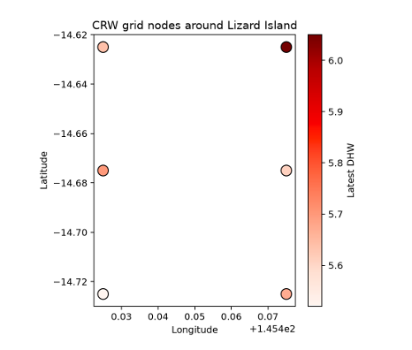
Table 1: Summary of the experimental data scope
Attribute | Value
Observation days | 5,513
Spatial grid cells | 6
Node-level observations | 33,078
Start date | 2010-01-01
End date | 2025-02-08
Spatially averaged SST | 26.94 degrees C
Spatially averaged DHW | 0.763
Maximum spatially averaged DHW | 8.787

3.2 Thermal stress progression over time
The spatially averaged DHW series in Figure 2 demonstrates the sparse and clustered characteristics of thermal stress periods. Most of the time, DHW is low or zero, but certain periods exhibit strong and prolonged increases. This indicates that the forecasting problem is not only a standard regression problem but also one of identifying the transitional phase from a stable baseline to cumulative thermal stress.
Regarding series morphology, DHW has distinct asymmetric features: the increasing phase usually occurs when HotSpot remains positive for many days, while the decreasing phase happens more slowly due to its weekly accumulative nature. This makes the 28-day forecasting problem heavily dependent on the prior state of DHW and the recent trends of thermal variables. In other words, the current value of DHW is not only a descriptive feature but also a state variable carrying the system's inertia information.
DHW peaks are primarily concentrated in the hot season, but the magnitudes differ significantly between years. The difference between years with the same seasonality shows that calendar features are insufficient for risk forecasting; models need to combine seasonality with anomalous signals like SST anomaly and HotSpot. This is why absolute thermal, thermal anomaly, and cumulative stress features are used simultaneously.
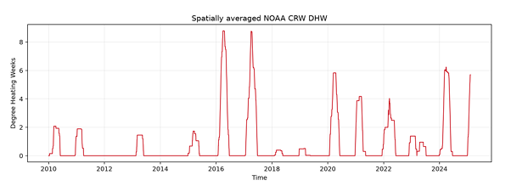
Figure 2: Spatially averaged DHW time series during the 2010-2025 period.
The years 2016 and 2017 are the two years with the highest DHW peaks, reaching 8.787 and 8.753 respectively. 2024 reached 6.238, 2020 reached 5.825, and early 2025 reached 5.698. These peaks show that the data contains some strong thermal stress events, but the number of severe events is still small compared to the total length of the observation series.

Table 2: Years with the highest DHW peaks
Year | Maximum DHW
2016 | 8.787
2017 | 8.753
2024 | 6.238
2020 | 5.825
2025 | 5.698
2021 | 4.172
2022 | 4.025
2010 | 2.075
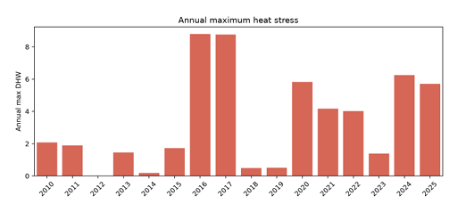
Figure 3: Annual maximum DHW during the 2010-2025 period.
3.3 Alert class distribution
The alert label distribution in Figure 4 shows very clear class imbalance. Out of 33,078 node-level observations, No Stress accounts for about 74.08%, Watch accounts for 20.41%, Warning accounts for 3.95%, Alert Level 1 accounts for 1.40%, and Alert Level 2 accounts for only 0.17%. In other words, classes carrying strong warning significance represent just a tiny fraction of the data.
This distribution shows the data has a "long baseline, short event" structure. Most of the time, the system is in a normal state or just starting to be monitored, whereas periods of high alert appear briefly and infrequently. For machine learning, this increases the risk of the model biasing towards the prevalent class. For practical applications, however, this is exactly the most important part because rare classes typically hold higher management significance.
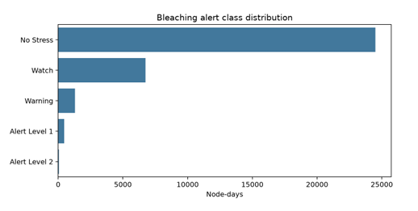
Figure 4: Distribution of observation counts by bleaching alert level.
Table 3: Alert class distribution in node-level data
Alert Class | Observations | Percentage
No Stress | 24,502 | 74.08%
Watch | 6,752 | 20.41%
Warning | 1,307 | 3.95%
Alert Level 1 | 462 | 1.40%
Alert Level 2 | 55 | 0.17%
This imbalance has a direct impact on model evaluation. A model biased towards predicting popular classes might achieve high accuracy but remain unhelpful in warning of severe events. Therefore, macro-F1, balanced accuracy, and event recall need to be considered alongside accuracy.
Additionally, the Warning class serves as a transition between Watch and Alert Level 1. If the model misclassifies Warning as Watch, the system might underestimate a forming risk; if it misclassifies Alert Level 1 as Warning, the system might miss a crucial warning threshold. Consequently, classification errors near the warning threshold must be interpreted more carefully than errors among baseline classes.
3.4 Feature correlation
The correlation matrix in Figure 5 indicates strong relationships among thermal variables. SST, SST anomaly, and HotSpot represent instantaneous or anomalous thermal states, whereas DHW reflects accumulated thermal stress. Because DHW is formed from prolonged stress, it is closely related to prior thermal variables but is not entirely identical to the SST on a given day.
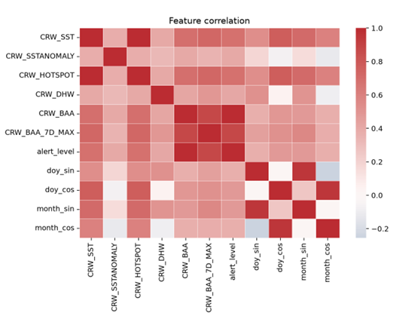
Figure 5: Correlation matrix between input features.
The experimental implication of high correlation is two-sided. On the positive side, the model has many consistent signals to identify thermal stress. On the downside, some features may contain overlapping information, increasing the risk of the model learning definitional relationships rather than early prediction indicators. Therefore, evaluation on a temporal test set is necessary to see if the model generalizes across different years.
Observing correlations also helps explain why tabular models can compete with deep models. When original variables and lag features already carry strong information about the thermal state, tree boosting models can learn nonlinear thresholds quite effectively. Conversely, the advantage of time series models only clearly manifests when it is necessary to learn the dynamic shape of the series, such as the rate of increase, the persistence of a HotSpot, or the length of the DHW accumulation phase.
4. Experimental Models
4.1 Tabular models
Random Forest is used as a strong baseline for tabular data due to its ability to learn nonlinear relationships and feature interactions without requiring linear assumptions. In the experiment, Random Forest uses original features, seasonal features, lags, and rolling statistics.
XGBoost is a gradient boosting model on decision trees, often achieving high efficiency on tabular data by sequentially optimizing weak trees and utilizing a regularization mechanism. LightGBM also belongs to the gradient boosting group but is designed for efficient training with a leaf-wise tree growth strategy and computational cost reduction techniques. These two models act as highly competitive baselines for deep learning models.
4.2 Deep time series models
LSTM is used to learn long-term dependencies in time series, partially overcoming the vanishing gradient problem of traditional recurrent networks. GRU is a more compact variant of gated recurrent architectures, generally having fewer parameters than LSTM while still being capable of retaining past information.
CNN-LSTM combines one-dimensional convolution and LSTM. The convolution block helps identify short-term patterns in the input window, such as rapid increases in HotSpot or SST anomaly; the LSTM then learns longer relationships between these patterns and the forecasting target.
The abbreviated Temporal Fusion Transformer utilizes an attention mechanism to learn time-based weights, suitable for series problems where not every day in a 90-day window has the same role. In the context of thermal stress, attention can help the model focus on continuous heating segments before DHW peaks.
4.3 Spatio-temporal models
ST-GNN represents each grid cell as a node in a graph and uses geographic distance to determine the degree of connection between nodes. This idea inherits the spirit of graph neural networks, in which a node's information is updated from neighboring nodes. For coral reef data, spatio-temporal models are meaningful when thermal stress has a propagating or spatially covariant structure.
5. Evaluation Setup
The problem is evaluated in two directions. For DHW forecasting, metrics include MAE, RMSE, and R^2. MAE indicates the mean absolute error, RMSE is more sensitive to large errors, and R^2 reflects the proportion of target variance explained by the model. For warning level forecasting, metrics include accuracy, balanced accuracy, macro-F1, and weighted-F1. Due to class imbalance, macro-F1 and balanced accuracy are more meaningful than accuracy when evaluating the ability to identify rare classes.
Furthermore, the report uses event precision, event recall, and event-F1 for event groups from Alert Level 1 and above. This group has operational significance because it reflects situations requiring early warning. In a conservation context, a low event recall means the system misses many high-risk events, while a low event precision means the system generates many false alarms. Depending on the intended use, these two metrics need to be balanced differently.
The test set is taken post-2022, while the training and validation sets are situated in prior periods. This split makes the evaluation closer to an actual operational scenario, where the model must predict future years from historical data.
6. Results, Evaluation, and Discussion
Table 4: Comparison of regression and classification results
Model | Group | MAE | RMSE | R^2 | Accuracy | Bal. Acc.
TFT | Deep | 0.436 | 0.805 | 0.799 | 0.819 | 0.423
CNN-LSTM | Deep | 0.487 | 0.905 | 0.746 | 0.822 | 0.436
XGBoost | Tabular | 0.449 | 0.945 | 0.724 | 0.808 | 0.415
LSTM | Deep | 0.563 | 0.994 | 0.694 | 0.825 | 0.438
Random Forest | Tabular | 0.424 | 0.999 | 0.692 | 0.786 | 0.396
Light GBM | Tabular | 0.511 | 1.005 | 0.688 | 0.805 | 0.414
ST-GNN | Deep | 0.607 | 1.076 | 0.642 | 0.757 | 0.367
GRU | Deep | 0.688 | 1.117 | 0.614 | 0.804 | 0.409
Comments: According to the DHW regression metrics, TFT performs best with an RMSE of 0.805 and an R^2 of 0.799, showing that the attention model effectively exploits temporal structure in predicting thermal stress. Random Forest achieved the lowest MAE (0.424) with stable mean error, but a higher RMSE, suggesting this model performs worse with large errors. LSTM reached the highest accuracy (0.825) with the best balanced accuracy (0.438), indicating relatively even performance across classes. The gap between models in terms of RMSE is not large (0.805-1.117), but the difference in R^2 is more distinct (0.614-0.799), emphasizing the role of the attention model.
Table 5: Comparison of detailed classification metrics and warning event detection
Model | Macro-F1 | Weighted-F1 | Event Prec. | Event Rec. | Event F1
TFT | 0.406 | 0.778 | 0.000 | 0.000 | 0.000
CNN-LSTM | 0.427 | 0.786 | 0.200 | 0.045 | 0.074
XGBoost | 0.323 | 0.773 | 0.044 | 0.029 | 0.035
LSTM | 0.425 | 0.797 | 0.048 | 0.045 | 0.047
Random Forest | 0.309 | 0.748 | 0.098 | 0.065 | 0.078
Light GBM | 0.321 | 0.774 | 0.101 | 0.058 | 0.073
ST-GNN | 0.355 | 0.704 | 0.000 | 0.000 | 0.000
GRU | 0.394 | 0.761 | 0.000 | 0.000 | 0.000
Comments: CNN-LSTM achieved the highest macro-F1 (0.427) with the best weighted-F1 (0.786), demonstrating a good balance among classes and stability with class weights. In detecting high alert events, Random Forest excels with a 6.5% event recall and a 7.8% event F1, suggesting the tabular model is more sensitive to rare patterns. LightGBM reached the highest event precision (10.1%). Conversely, TFT, ST-GNN, and GRU fail to detect warning events (event metrics = 0), despite TFT being excellent at regression. The gap between macro-F1 (0.309-0.427) and event metrics (0-0.101) is very large, proving the impact of class imbalance: models are good at general classification but miss rare events that possess high management significance.
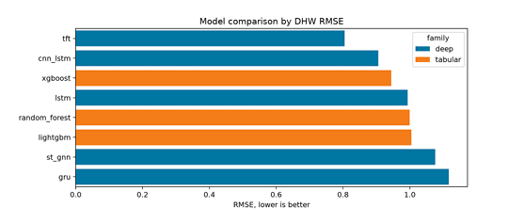
Figure 6: Model comparison by DHW RMSE.
The tabular model group remains highly competitive. XGBoost achieved an RMSE of 0.945, outperforming LSTM, Random Forest, and LightGBM. This indicates that the lag and rolling features successfully encoded much of the critical temporal information, sufficiently enough for tree boosting models to exploit effectively without requiring complex sequence architectures. Random Forest has the lowest MAE in the table but a higher RMSE than TFT and XGBoost, showing that this model is stable with average errors but poorer in cases of large errors.

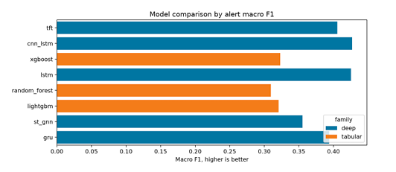
Figure 7: Model comparison by alert macro-F1.
For the classification problem, the accuracy of many models reached above 0.80, but macro-F1 only ranged between 0.309 and 0.427. The massive gap between accuracy and macro-F1 confirms the effect of class imbalance. Looking solely at accuracy, LSTM might be considered the best model for reaching 0.825; however, CNN-LSTM has a higher macro-F1, reflecting a better balance between classes. Therefore, for the warning problem, model selection should not be based merely on accuracy.
When solely examining events from Alert Level 1 and above, detection capabilities remain limited. Random Forest can catch more warning events than several other models, whereas TFT, despite predicting DHW the best, does not perform well in detecting rare events under the current configuration. This result demonstrates that optimizing DHW regression does not automatically lead to good detection of high alerts. A model with a low DHW error can still predict below the warning threshold during rare periods, leading to missed events.
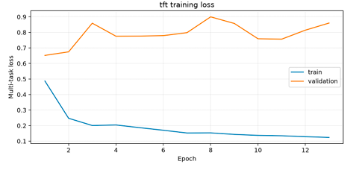
Figure 8: Training and validation loss curves of the TFT model.
The TFT training curve shows that the validation loss decreases in the early phase and is controlled using early stopping. This indicates that the training process does not simply select the final epoch, but rather the checkpoint with the best validation loss. However, evaluations based on event recall show a need to supplement event-oriented optimization objectives, such as increasing rare class weights, using focal loss, oversampling by thermal stress phase, or adjusting warning thresholds post-training.
ST-GNN has not shown its advantage in the current experiment. A reasonable cause is that the spatial graph only has six nodes and a narrow geographic scope. With such small data, the added spatial information is not rich enough for the graph model to surpass sequence or tabular models. If the observation scope were expanded to multiple reef clusters, ST-GNN might have the conditions to better exert its role.
Overall, the experimental results show that the DHW forecasting problem is feasible with the existing NOAA CRW data, but the severe event warning problem remains significantly more difficult. For operational monitoring objectives, models need to be evaluated using event-oriented metrics rather than just RMSE or accuracy.
7. Conclusion
The report presented a coral bleaching forecasting experiment around Lizard Island based on NOAA Coral Reef Watch data. The features SST, SST anomaly, HotSpot, DHW, BAA, and BAA 7-day maximum composite complement each other: SST describes the immediate thermal state, SST anomaly and HotSpot reflect thermal anomalies, DHW represents cumulative stress, and BAA translates physical information into operational warning levels.
Among the compared models, TFT achieved the lowest DHW error, CNN-LSTM achieved the highest macro-F1, and tabular models like XGBoost, Random Forest, and LightGBM maintained their roles as strong baselines. Analysis and evaluation demonstrate that class imbalance is the primary challenge reducing the ability to detect Alert Level 1 and above. Therefore, the next important improvement direction is to optimize models according to event warning objectives, instead of only optimizing the average DHW error.
References
- [1] NOAA Coral Reef Watch. (2026) NOAA Coral Reef Watch Daily 5 km Satellite Coral Bleaching Heat Stress Products. Accessed: Jun. 21, 2026. [Online]. Available: https://coastwatch.pfeg.noaa.gov/erddap/info/NOAA_DHW/index.html
- [2] L. Breiman, "Random forests," Machine Learning, vol. 45, no. 1, pp. 5-32, 2001.
- [3] T. Chen and C. Guestrin, "XGBoost: a scalable tree boosting system," in Proc. 22nd ACM SIGKDD Int. Conf. Knowl. Discovery Data Mining, 2016, pp. 785-794.
- [4] G. Ke, Q. Meng, T. Finley, T. Wang, W. Chen, W. Ma, Q. Ye, and T.-Y. Liu, "LightGBM: a highly efficient gradient boosting decision tree," in Advances in Neural Information Processing Systems, vol. 30, 2017, pp. 3146-3154.
- [5] S. Hochreiter and J. Schmidhuber, "Long short-term memory," Neural Computation, vol. 9, no. 8, pp. 1735-1780, 1997.
- [6] K. Cho, B. van Merriënboer, C. Gulcehre, D. Bahdanau, F. Bougares. H. Schwenk, and Y. Bengio, "Learning phrase representations using RNN encoder-decoder for statistical machine translation," in Proc. 2014 Conf. Empirical Methods Natural Language Processing, 2014, pp. 1724-1734.
- [7] B. Lim, S. O. Arik, N. Loeff, and T. Pfister, "Temporal fusion transformers for interpretable multi-horizon time series forecasting," International Journal of Forecasting, vol. 37, no. 4, pp. 1748-1764, 2021.
- [8] T. N. Kipf and M. Welling, "Semi-supervised classification with graph convolutional networks," in Proc. Int. Conf. Learning Representations, 2017. [Online]. Available: https://arxiv.org/abs/1609.02907

